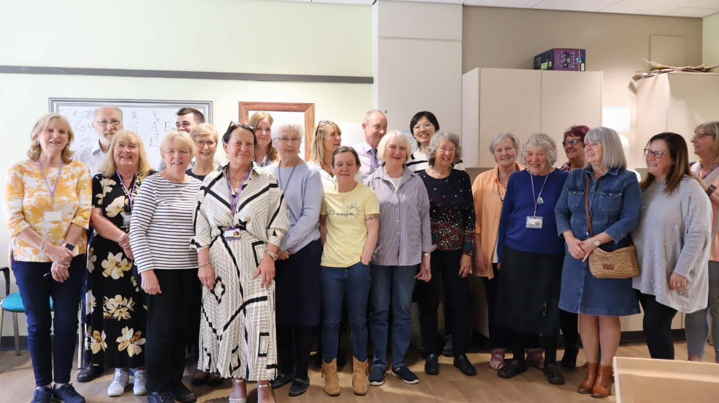

Bee Brilliant!

Just like bees keep the world buzzing, you help keep Town Break thriving!

Our volunteers are the heart of everything we do.  
  
Whether you’re pouring a cuppa, chatting on the phone, cheering on a fundraiser, or walking miles in a Kilt Walk - you’re making a real and lasting difference to people living with dementia.

We never take that for granted. That’s why we’re committed to making your time with us as rewarding, supportive, and enjoyable as possible.

Thank you for helping Town Break buzz with life and kindness.

|  |  |  |  |  |
| --- | --- | --- | --- | --- |
| **YOUR CONTACT DETAILS** | | | | |
| Name |  | | Likes to be known as |  |
| Gender |  | | Date of Birth |  |
| Address Council Area  Postcode |  | | | |
| Telephone |  | | | |
| Mobile |  | | | |
| Email |  | | | |
|  | | | | |
| EMERGENCY CONTACT 1 | | | | |
| Name | |  | | |
| Relationship to you | |  | | |
| Address | |  | | |
| Contact number | |  | | |
| Email | |  | | |

|  |  |
| --- | --- |
| EMERGENCY CONTACT 2 | |
| Name |  |
| Relationship to you |  |
| Address |  |
| Contact number |  |
| Email |  |

### Please indicate how you may like to help Town Break

Let us know what areas you are interested in by ticking one or more of the boxes below.

|  |  |
| --- | --- |
| **I am applying for a voluntary role within …** | |
| Services |  |
| Office administration |  |
|  | |
| If you wish to help in a different way from those mentioned above, please tell us below | |
|  | |

### Please tell us about your skills and experience

We’d love to hear about your skills, experience and what you enjoy doing – this helps us find the best volunteering role for you.

You might want to include things like:

* Any work or volunteering you’ve done before
* If you’re a people person, love organising, or enjoy speaking to groups
* Whether you use a computer, drive, or speak other languages
* What your current situation is (working, studying, retired, job seeking)
* Any personal experience you have with dementia
* What you hope to get from volunteering with us

If you’re applying for a specific role, feel free to tell us how your experience fits.

You can continue on another sheet or attach a CV if that’s easier.

|  |  |  |  |
| --- | --- | --- | --- |
|  | | | |
| Are you more comfortable in the limelight or behind the scenes? | | | |
|  | | | |
| How much time can you offer us? | | | |
| Short term |  | Monday |  |
| Open-ended |  | Tuesday |  |
|  | | Wednesday |  |
| Thursday |  |
| Friday |  |

### Your Wellbeing Matters

Is there anything about your health we should be aware of to support you in your role?  
We want to make sure your volunteering experience is comfortable, safe, and inclusive. If you have any health conditions, access needs, or require additional support or equipment, please let us know below so we can plan accordingly.

This information will be kept confidential and only shared with relevant staff if needed to support you properly.

|  |
| --- |
|  |

### How did you hear about volunteering with Town Break?

|  |  |  |  |
| --- | --- | --- | --- |
| Town Break volunteer | |  | |
| Poster | |  | |
| Social Media | |  | |
| Website | |  | |
| Other | |  | |
| References | | | |
| Please provide the names and contact details of two people who know you well and can tell us about your suitability for a voluntary role with Town Break. These should not be family members, but could include former colleagues, teachers, neighbours, or anyone who can speak positively about your character, skills or experience. | | | |
|  | | | |
|  | Reference 1 | | Reference 2 |
| Name |  | |  |
| Relationship |  | |  |
| Address |  | |  |
| Email |  | |  |
| Telephone |  | |  |

### Self-declaration

At Town Break, the safety and wellbeing of the people we support is our top priority. Because of the nature of our work with people living with dementia and their carers, all volunteers are required to be a member of the Protecting Vulnerable Groups (PVG) Scheme for regulated work with protected adults before starting their role.

As part of this process, and in line with current Scottish legislation, we ask all prospective volunteers to make a self-declaration regarding criminal convictions.

The Rehabilitation of Offenders Act 1974 (Exclusions and Exceptions) (Scotland) Order 2013 applies to volunteering roles with Town Break. This means that, for roles involving regulated work, you must disclose all unspent and certain spent convictions, even if they would normally be considered “spent” for other purposes.

We treat this information in the strictest confidence and will only consider it in relation to the role you are applying for. A criminal conviction will not automatically prevent you from volunteering – we assess each application individually, with fairness and care.

However, failure to disclose relevant information may result in your application being withdrawn or your volunteering role being ended.

If you have any questions or are unsure about what to declare, we encourage you to speak to us in confidence.

|  |  |
| --- | --- |
| **Please tick the appropriate statement, which applies to you** | |
|  | I have read and understood the above and have convictions to declare (If yes, please provide details below) |
|  | I have read and understood the above and I have no convictions to declare |
|  | |
| **Do you have any police, court proceedings pending against you?** (please circle) If yes, please provide details below. | |
| Yes |  |
| No |  |
| Provide details here: | |

I confirm that, to the best of my knowledge, the information provided on this form is accurate. I agree to abide by the rules and uphold the values and behaviours of Town Break.

I understand that my volunteering role may involve sensitive issues and situations, and I commit to maintaining confidentiality at all times.

I consent to Town Break processing the information I have provided in accordance with the UK General Data Protection Regulation (UK GDPR) and relevant data protection laws.

|  |  |
| --- | --- |
| Name |  |
| Signature |  |
| Date |  |

Please return your completed form to: [admin@townbreak.org](mailto:admin@townbreak.org) or Town Break, 1 Springkerse Road, Stirling, FK7 7SN

Please note: All information provided will be stored and handled in accordance with data protection legislation. We will never share your information without your consent unless required to do so by law.