Hello!

**#BEEamazing**

We are Town Break. We support people affected by dementia. We deliver dementia support services within a safe and inclusive environment throughout Forth Valley.

Thank you so much for choosing to give your time, skills and enthusiasm to us as a volunteer. This handbook is the first part of your journey to help people affected by dementia. We want to make sure you have a great experience.



**PSSST…** we call our volunteers superstars because they are!

TOGETHER we’re a community of people behind people, like our Miriam. She made the tea that was right there for Benny, who baked the shortbread and scones for Laura to sell at our Christmas fayre. Laura gave the funds to Adam, who was right there for Muhammad, so he could be right there for his wife Amira.

### Everything you need, right here.

Everything you need, right here. 2

Your handy address book 3

Our hive 4

Dementia & Alzheimer’s are the same thing right? 5

Our history 6

Our mission statement 6

Why we’re here 6

Bee amazing! 7

Our pledge 7

We want our brand to shine 8

Volunteer success story 8

Our Vision 9

A role for everyone 9

We’re so proud of you 10

Settle in for the serious bit 10

Privacy matters 11

We’ve got your back 12

Safeguarding tip 12

We love talking 13

Thank You! 14

One last thing… 14

To prepare your Town Break identification badge we require a passport style photograph. We can’t to see you! 14

### Your handy address book

Some helpful information

Remember, your Services Coordinator is your first port of call for support and information while you’re volunteering with us.

You can always go to them with any compliments, comments or complaints.

**Board of Trustees**

**Management**

Helen Duncan [Chief Executive Officer]

**Office based Staff**

Daniel Keane [Operations Manager]

Kath Phipps [Finance Manager]

Penny Casey [Admin/resource coordinator]

**Lead Service Coordinators**

Lesley Milne

Davina Pilley

**Carer Coordinator**

Davina Pilley [Stirling/Clackmannanshire & Falkirk]

**Community Fundraiser**

Leighann Rushforth

**Service Coordinators**

Beth Colbecki

Shirley Laycock

Jan Palmer

Anne Yau

Scott Marshall

Laetitia Pannetier

Kirstie Inglis

Margit De Bru

Phone number: 01786 641 841

Email: *[FIRSTNAME]*@townbreak.org

**If you have any other queries or concerns, please contact our CEO.**

Name:Helen Duncan [helen@townbreak.org]

**Head office address:**

Town Break

1 Springkerse Road

Stirling

FK7 7SN

Number: 01786 641 841

Email: [admin@townbreak.org](mailto:admin@townbreak.org)

Website: www.townbreak.org

Dementia & Alzheimer’s are the same thing right?

**Dementia is actually an umbrella term.**

It is a syndrome– usually of a chronic or progressive nature that leads to deterioration in cognitive functioning (i.e. the ability to process thought) beyond what might be expected from the usual consequences of biological ageing.

It affects memory, thinking, orientation, comprehension, calculation, learning capacity, language, and judgment. Consciousness is not affected. The impairment in cognitive function is commonly accompanied and occasionally preceded, by changes in mood, emotional control, behaviour, or motivation.

Dementia results from a variety of diseases and injuries that primarily or secondarily affect the brain, such as Alzheimer's disease or stroke.

Dementia is currently the seventh leading cause of death among all diseases and one of the major causes of disability and dependency among older people worldwide. Dementia has physical, psychological, social, and economic impacts, not only for people living with dementia but also for their carers and families.

There is often a lack of awareness and understanding of dementia, resulting in stigmatisation and barriers to diagnosis and care.

There are many different forms of dementia. Alzheimer's disease is the most common form and may contribute to 60-70% of cases. Other major forms include vascular dementia, dementia with Lewy Body, frontotemporal dementia. Dementia may also develop after a stroke or in the context of certain infections.

Our history

30 years ago, the idea of Town Break was first discussed when Rosas Mitchell, Pat Smith (Alzheimer’s Scotland), and Central Regional Council (presently Stirling Council) highlighted the need for local statutory support for People Living with Dementia (PLwD) and their unpaid carers.

The idea was that there would be a ‘safe’ place for PLwD to meet, and have a cuppa and a chat. This allowed their unpaid carers some respite to meet up with a friend, do a bit of shopping, or do whatever they desired for a few hours. And so, ‘Town Break’ was born and held its first support group on 16 September 1992 in Stirling Baptist Church.

Over the years, we have grown. And by grown, we mean grown! We now offer multiple dementia-specific support services across Forth Valley.

### Our mission statement

“To inspire and enable people, across Forth Valley, to live well with dementia.”

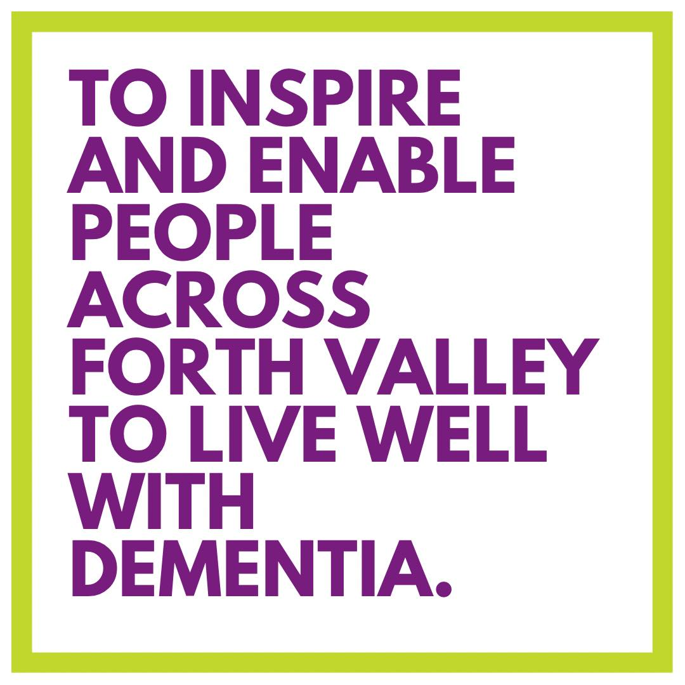

Why we’re here

There is an estimated 2,500 (2022 figures) PLwD in Forth Valley. We are here to support these individuals, their unpaid carers, and their families.

Global picture: The World Health Organization Worldwide (WHO) estimates globally that around 55 million people live with dementia. As the proportion of older people in the population is increasing in nearly every country, this number is expected to rise to 78 million in 2030 and 139 million in 2050.

To meet this well-projected rise across Scotland (and the World) we must look towards Town Break’s evolution and sustainable growth.

Bee amazing!

**Bees are vital to humankind and you are just as important to us!**  
  
You’re our everything!

You are massively important to Town Break because you and all our other amazing volunteers make it possible for us to support people affected by dementia. Whether you are fundraising, making a cuppa, on the phone or doing the Kilt Walk, you are making a huge difference to people affected by dementia.

We never forget this, which is why we take every step possible to make sure your experience with Town Break is as rewarding and enjoyable as possible.

Our pledge

In other words, we will:

1. Always treat you with respect, consideration and appreciation.

2. Make sure you have the best possible experience by sticking to our   
Town Break Volunteering Standards.

3. Tell you about the responsibilities of your role and Town Break policies so you know where you stand and have what you need to deliver your best.

4. Give you appropriate training for your role and opportunities to develop your skills.

5. Support you by holding regular meetings and informal discussions.

6. Provide fair, honest and timely feedback regarding any concerns with performance and/or conduct.

7. Update you on how your contribution makes a difference to people affected by dementia.

8. Create a safe and respectable environment for you to volunteer.

9. Never forget the enormous contribution you make.

10. Be there for you.

We want our brand to shine

So it is important that everyone uses it properly. Our brand is more than our logo. It is also:

Our reputation: who we are, what we do, and what we mean to others.



Our promise to people: what they should expect from us.

The experiences we give to everyone we meet. These experiences affect everything people understand, think and feel about us.

So understandably, we need to take care of it. As a Town Break volunteer, you will be our representative to a wide range of people.

Volunteer success story

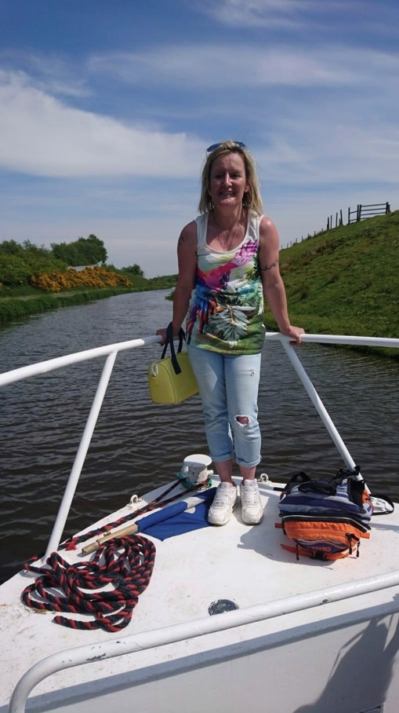  
Nine years ago, Leigh enquired about volunteering with Town Break, and she is still here!

Leigh is a familiar face with staff and volunteers. She can be found at a number of our groups deep in conversation over a cuppa, taking part in activities or helping out in the kitchen. Leigh loves arts, gardening and cooking. She even completed a Charlie Chaplin video for us throughout lockdown. She really is a superstar!

She attended a course at Stirling University and learned all about dementia and how it affects people differently.

Her favourite memory whilst volunteering was the trip to the Botanical Gardens in Edinburgh!

### Our Vision

A society across Forth Valley where people living with dementia (PLwD) and their unpaid carers are supported and empowered through social inclusion and cognitive stimulation.  
  
and how you help to bring it to life!  
  
It’s simple. We can’t do it without you. Volunteers like you are essential in helping us make our strategy come to life. Volunteers allow Town Break to move forward, develop and evolve.

A role for everyone

Whatever you’re good at is great with us – whether you’re a top organiser, an expert tea maker, a wonderful listener. Brilliant!

There are many different ways you can volunteer for Town Break. We can’t wait to make the most of your skills and experience. Because we can see, the huge difference volunteers like you make to people living with dementia.  
  
Some of the things you could do include:

• be part of our fundraising team.

• providing a listening ear.

• befriending.

• support at one of our groups.

• office support.

If someone you know has been affected by dementia, channelling that experience into your volunteering will help others through their journey. You’ll also get great work and life experience as a volunteer.   
  
We welcome all ages, backgrounds and experiences. What makes you special will help us reach more people in communities that Town Break hasn’t reached yet. Every single volunteer counts.

We’re so proud of you

Our volunteers are all superstars. Our volunteers come from all ages, ethnicities, and working backgrounds and start their volunteering journey at different stages of their lives.

Whatever your experience of dementia, you'll be helping us to make a huge difference to people who really need support.

The diversity of our volunteers helps us reach more communities that may not be aware that Town Break is there for affected by dementia.

Settle in for the serious bit

**Guidance and procedures**

While you are volunteering with us, we need you to follow Town Break’s core procedures. This is to ensure that volunteering is safe, legal and consistent with other areas of Town Break’s work. You should be familiar with our guidance on:

• Expenses.

• Health and safety including lone working and driving.

• Equality, diversity and inclusion.

• Keeping data safe.

• Safeguarding.

• Problem solving.

• Cash handling (if you are fundraising).

Your Services Coordinator will help you identify which procedures apply to your role. They're also there to offer help so do get in touch if you have any questions.

To receive a PDF of the above policies and procedures please speak with any member of staff or email [admin@townbreak.org](mailto:admin@townbreak.org)

Privacy matters

**Keeping data safe**  
  
It’s so important that people feel they can trust us to do the right thing by them. A huge part of this is making sure we keep private details private. In fact, there are laws about privacy that you’ll have to follow, especially when it comes to sharing and keeping information about people that could be used to identify them. Put yourself in their shoes and you’ll see why this sort of protection is needed.

**Here’s an example:**   
  
Imagine that a friend wants to take a photo of you. How would you feel if they said that they wanted to keep a copy as a memory and not share it with anyone else, versus if they told you it was going to be uploaded to their Facebook, Twitter and Instagram?

Would you want to check the photo yourself before it’s uploaded onto social media? Would you strike a particular pose? Would you rather they didn’t take your photo or upload it at all?

We all feel differently about our personal data being used in each way, so it’s really important that people are fully informed about and agree to how we will use their data.

It all boils down to a few simple things you need to be aware of when you collect, use and store data like names and addresses

**N.B.** Please note that digital media (photographs and videos) is managed by Town Break and has to comply with Data Protection laws (including General Data Protection Regulation ‘GDPR’).

No photographs should be taken of Town Break clients on personal devices.

We’ve got your back

**Keeping everyone safe**

Volunteering with us should be safe and enjoyable.

As a volunteer, you are expected to follow some simple rules while volunteering with us and we have a duty to make sure you have the right information, training and support to carry out your role safely.

Keeping volunteers, staff, supporters, people who use our services and the public safe from harm is our number one priority.

All volunteers and staff are subject to a PVG check prior to commencing their role. For this, we require three forms of identification two of which should be photographic (i.e. passport or driving license)

Safeguarding tip

People living with dementia can be more vulnerable because of their diagnosis. As a charity, our supporters and people we support trust us and may share aspects of their lives that concern us. It’s worth bearing in mind that any adult can become vulnerable.

Town Break’s Adult Protection Policy is in place to support volunteers, staff and people affected by dementia. A copy of the Adult Protection Policy can be emailed to you on request. [admin@townbreak.org]

If the situation is not life threatening, contact your Services Coordinator. They are your first point of contact and will notify the appropriate individual or agency.

In any situation where someone’s life is in danger, ALWAYS CALL 999.

### We love talking

We really like getting in touch to keep you up to date with lots of things like training, superstar celebrations and everything that’s crucial to your role. We also love to hear from you so please do tell us how you’re getting on or if there’s anything you need help with. Volunteering with Town Break is very much a two-way street and we are always ready to listen and chat things through.

Here are three great ways to keep in touch:

**Newsletters:**

One of the best ways to keep up to date with all things Town Break. They’re a great round-up of what’s happening, including training opportunities and events, and will really help you in your role. If you opt-in, you will automatically receive news content to your email address.

Sign up for monthly newsletters: [Signup (mailerlite.com)](https://dashboard.mailerlite.com/forms/68939/57332389091739617/share?fbclid=IwAR3vqp_BEhTiclL12wUmUU328XJbjCI1ZyyjoK05IR9mdNffkvfF2ObE11Q)

**Social media:**

Give our social media accounts a like/ follow and share the work we do with others. Town Break is on all the main channels including:

Facebook: @TownBreak

Twitter: @TownBreak

Instagram: @town_break

TikTok: @town_break

**Services Coordinator:**

Remember your Services Coordinator is always there if you have any questions, need a listening ear, or want more information on your role. They want to help you make the most of your time with us, so if you have ideas on how to make it better, tell them about it.

Thank You!

Lastly, we wanted to say a massive thank you on behalf of Town Break and, more importantly, the many people you make a difference to every day.

Together, we’re here to help people affected by dementia to live life as fully as possible, so whatever dementia throws their way, we’re right there with them.

### One last thing…

**Please note**: all volunteers will be on a three-month probationary period. All volunteers will meet with a member of staff at the end of this period for an informal discussion.

To prepare your Town Break identification badge we require a passport style photograph. We can’t to see you!



**#wearetownbreak**